**Excel Assignment – 15**



**1. Create a Pivot table and show what the main export product is?**

Main product is Scale in stationary category which costs at **3,40,295**.

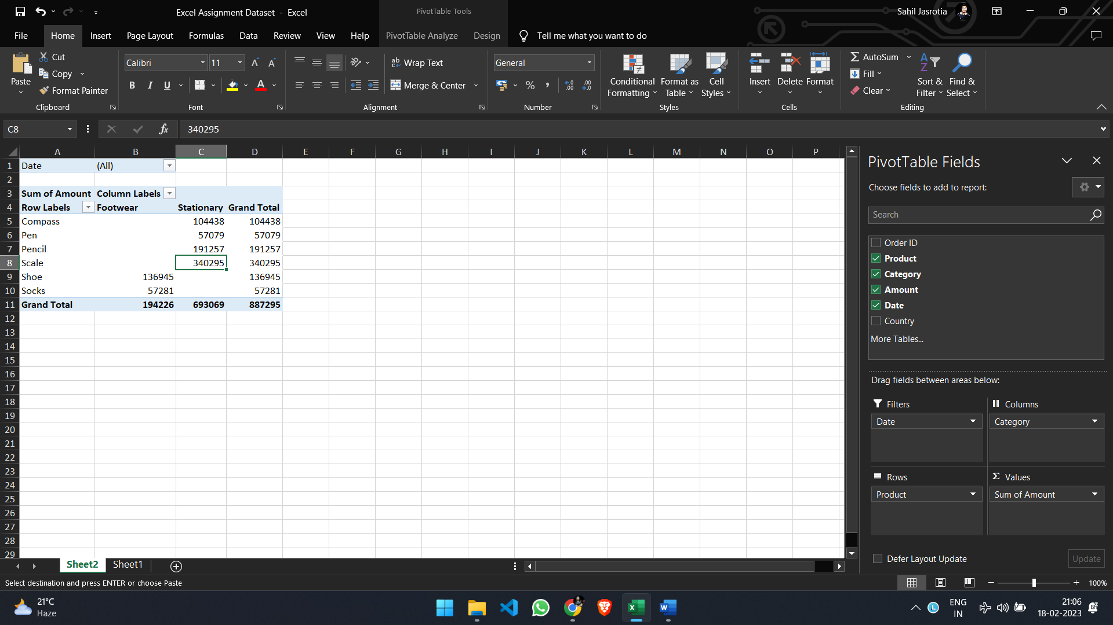

**2. Create a bar graph showing the amount spent for each product?**

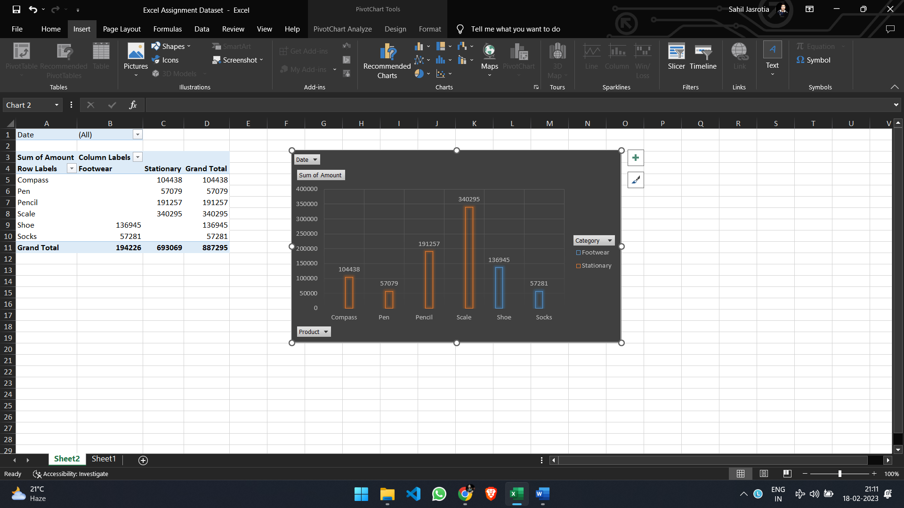

**3. Create a Pivot table to show the sales in each city.**

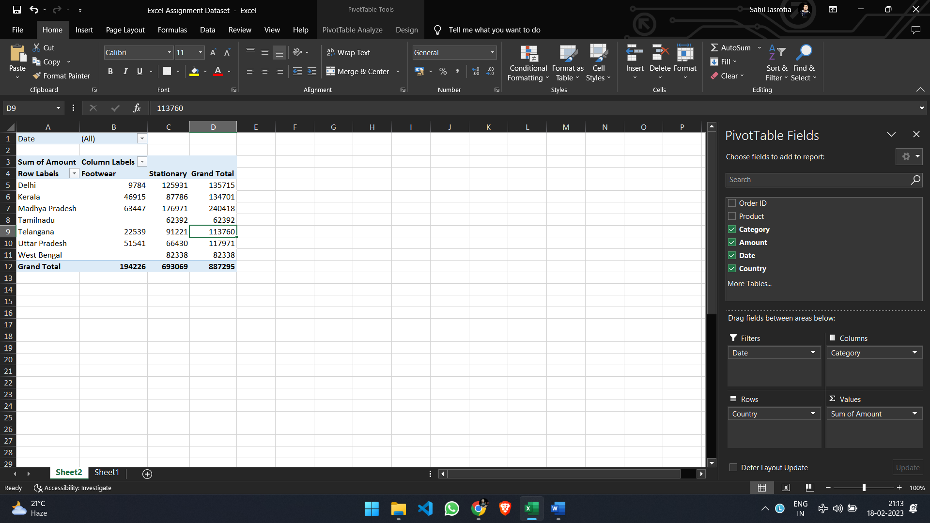

**4. Create a chart showing the amount spent for each product in each city.**

